

# SOLUTION OF THE ASSIGNMENT

INTRODUCTION:

WIFI Stands For Wireless Fidelity.

Wi-Fi is the wireless technology used to connect computers, tablets, smartphones and other devices to the internet. Wi-Fi is the radio signal sent from a wireless router to a nearby device, which translates the signal into data you can see and use.

Wi-Fi is a wireless networking technology that allows devices such as computers (laptops and desktops), mobile devices (smart phones and wearables), and other equipment (printers and video cameras) to interface with the Internet. It allows these devices--and many more--to exchange information with one another, creating a network.

What is the security of WPA/WPA2 Wi-Fi Routers with various Wi-Fi type protocols?

Did you know that your Wi-Fi connection uses one of four different security types? While all of them are different, they're not all equal; thus, it's essential to learn what security type your Wi-Fi is using.

Let's explore the four Wi-Fi security types and see which ones the best is to use:

1. The Wired Equivalent Privacy (WEP) Protocol.

2. The Wi-Fi Protected Access (WPA) Protocol.

3. The Wi-Fi Protected Access 2 (WPA2) Protocol.

4. The Wi-Fi Protected Access 3 (WPA3) Protocol.

Requirements for accessing security of a wifi :

1. A Laptop with kali linux installed and connected to an virtual machine
2. Network Adapter Supporting monitor mode
3. Wifi router of yours having security of wpa/wpa2 enabled
4. WPS mustend

Steps Required for accessing the password of an wifi:

1. First we must find the version of kali Linux and VM WARE we are using:

For that we must write 1) “lsb_release –a command”

2) uname-a

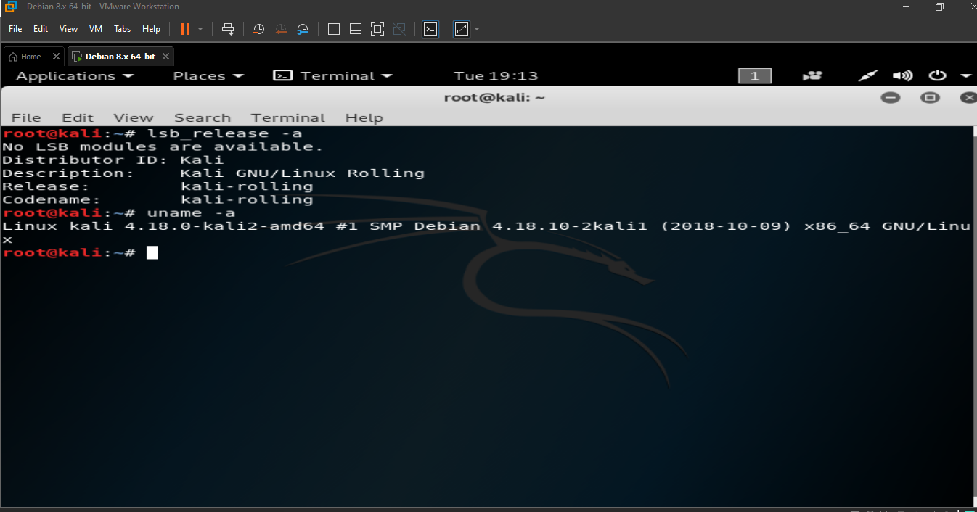

1. Now we must check our Network Adapter is working or not on the Linux by using the following commands:

* iwconfig
* ifconfig

which shows the information of the networks running on the device,network manager

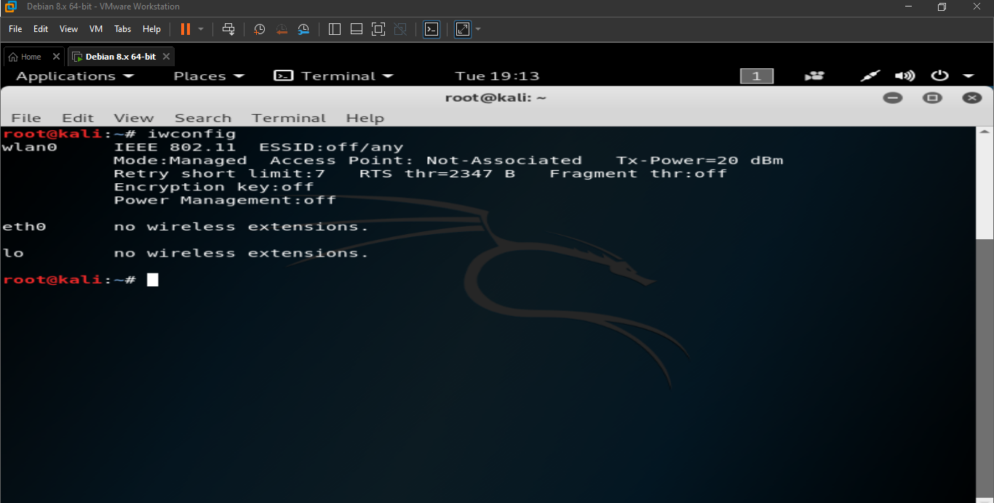

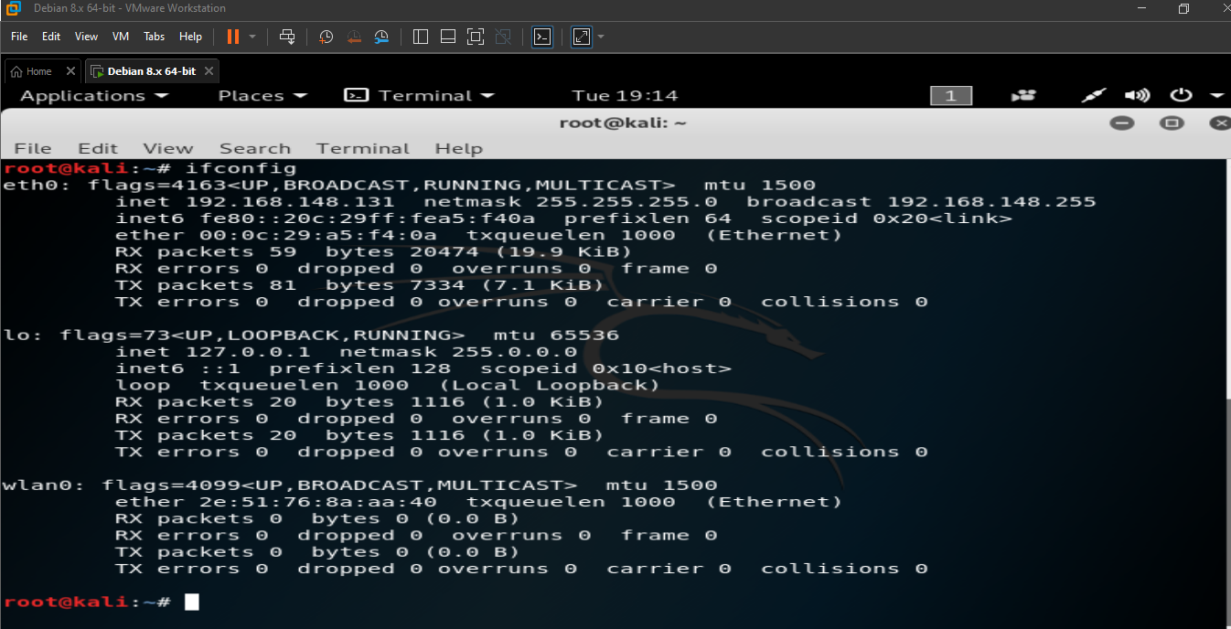

The above mentioned images shows us the details of the network devices connected to the Linux

1. airmon-ng

It is used for checking Wi-Fi port details

Start monitor mode by commands :

iwconfig && sudo airmon-ng start wlan0 && sudo airomon-ng check kill(to kill network manager)

This makes enabling monitor mode in wlan and runs like a monitor and this makes traffic due to which we cannot use internet or browse anything

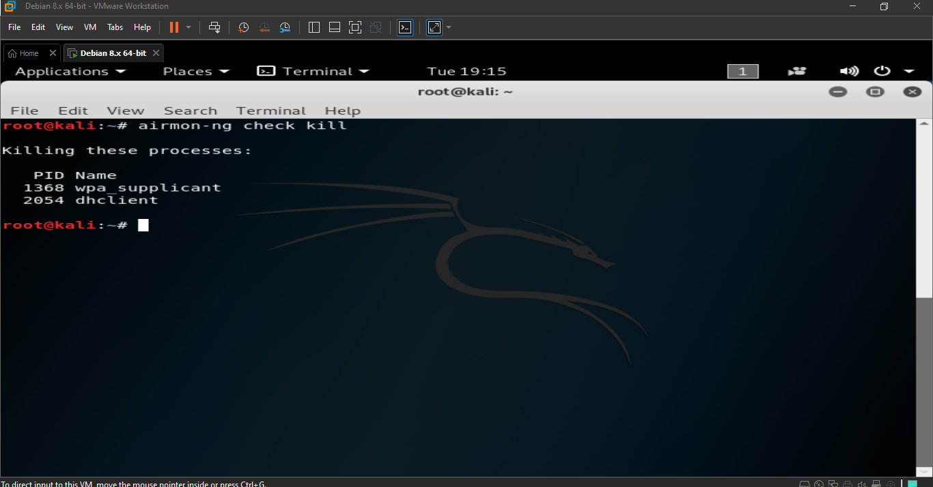

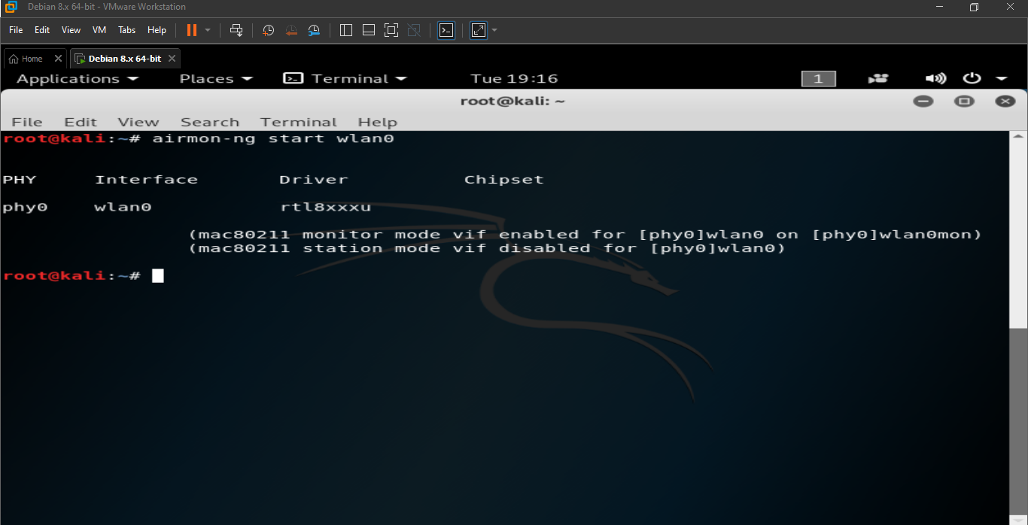

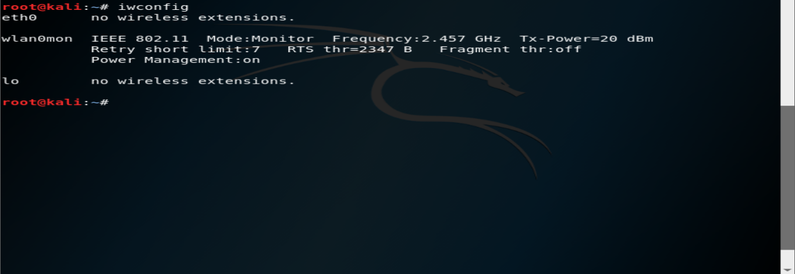The above shown images depict the kali Linux is in monitor mode.

5.airodump-ng wlan0mon

By using this command we can get AP’S MAC address and channel

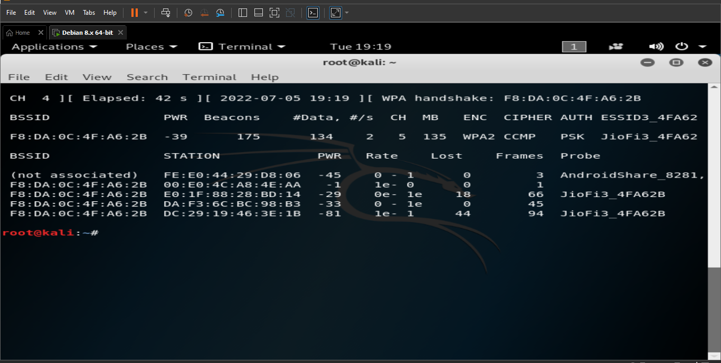

6.We can get target focused by using bssid

airodump-ng wlan0mon –bssid (bssid)

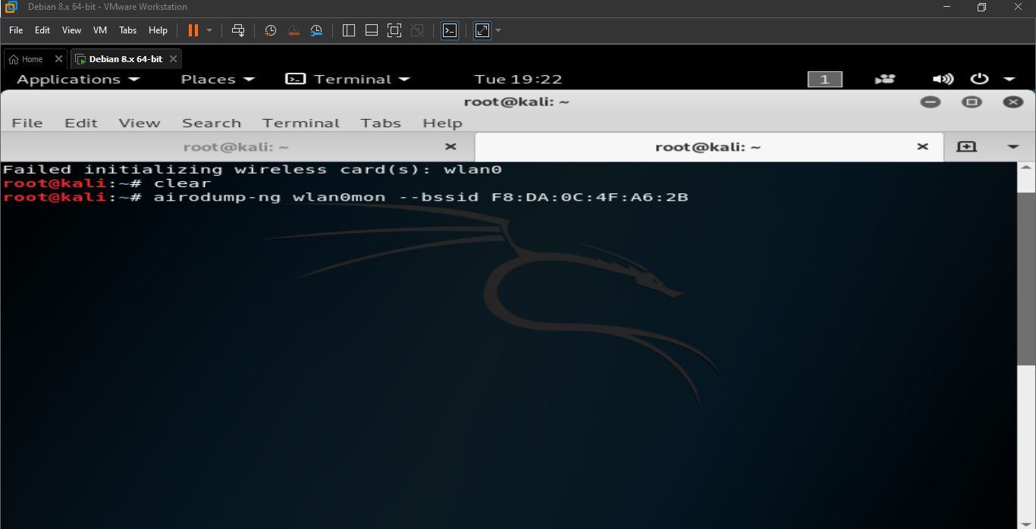

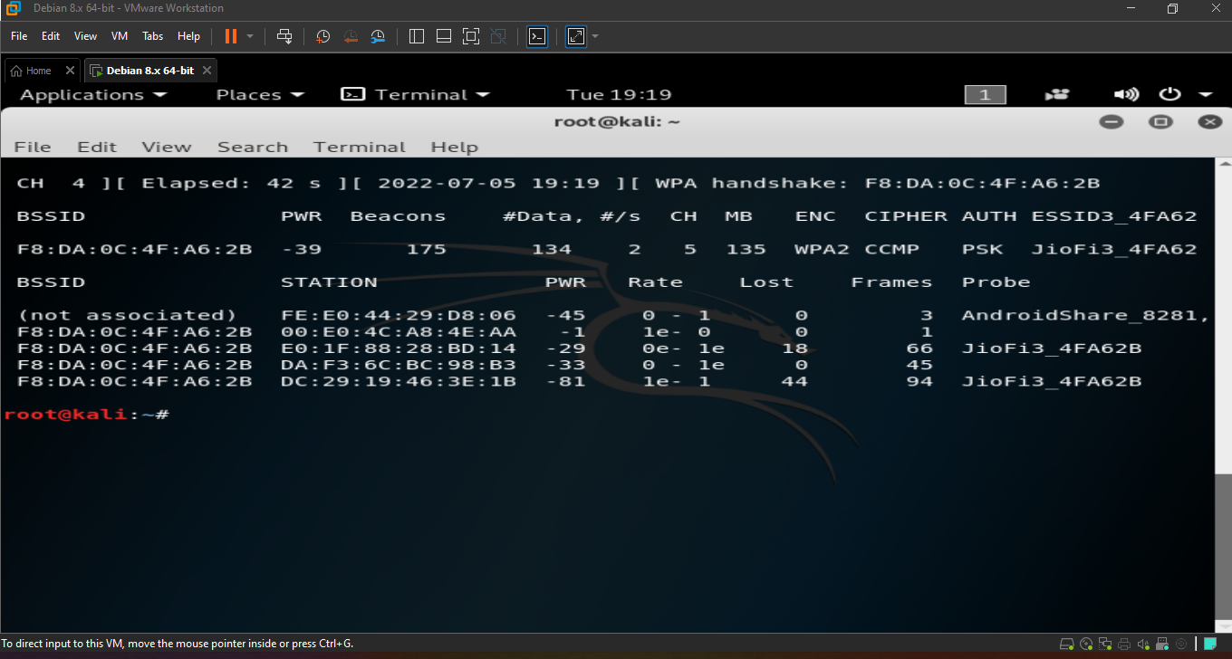

7.For getting handshake and other data store in a file ,so keep file name as:

Airodump-ng wlan0mon --bssid (bssid) -write JIOFI

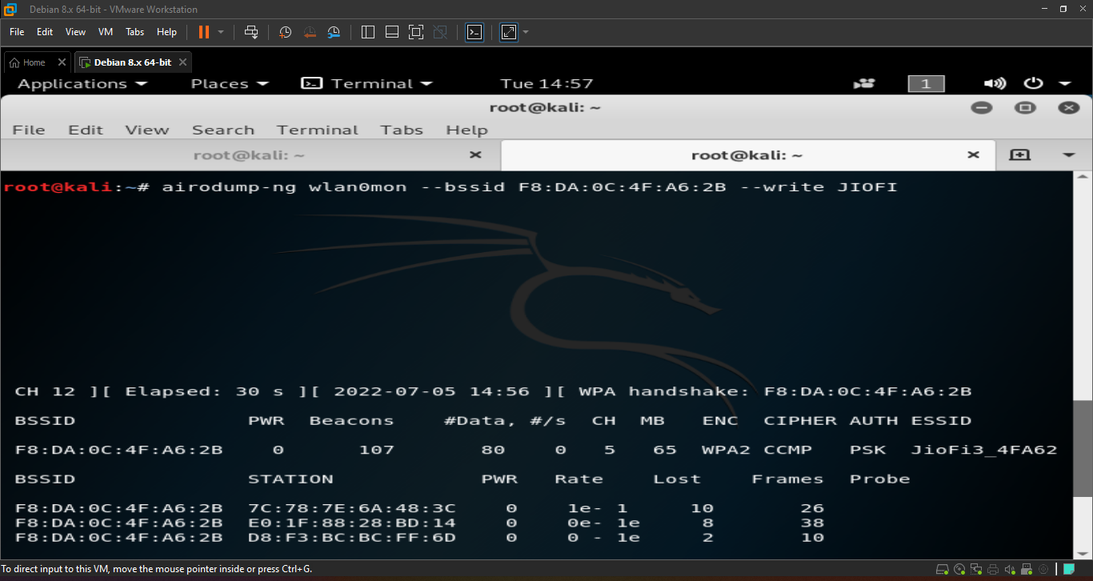

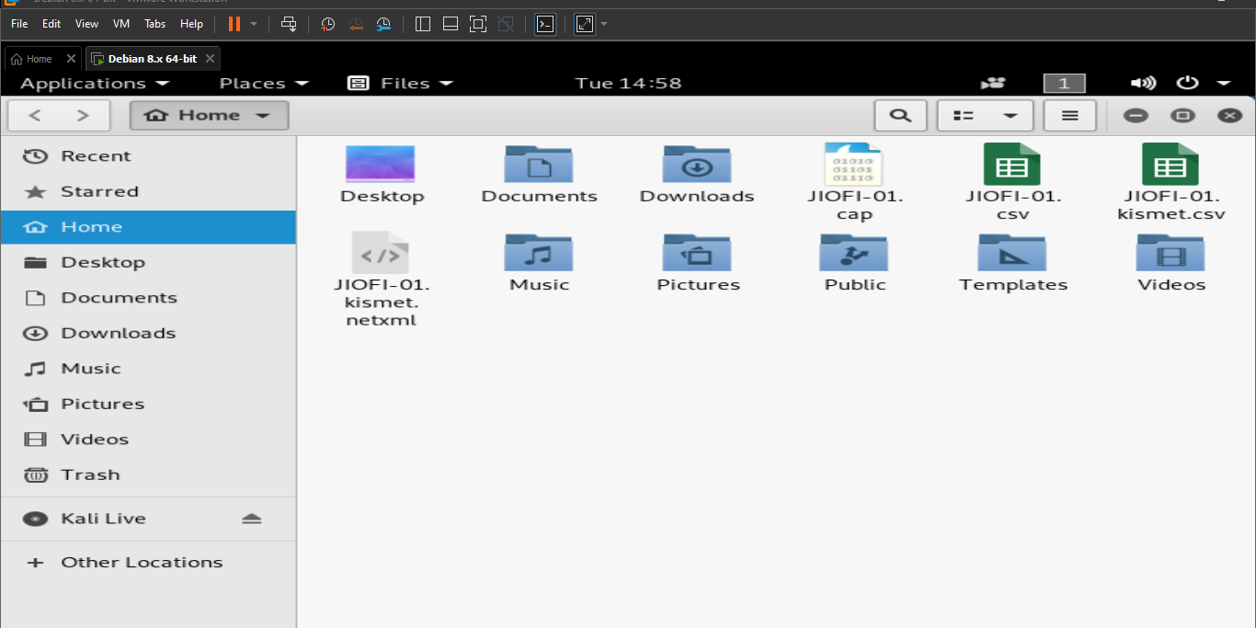The above picture depicts us that a file as created.

8.Waiting for handshake to be stored:

we must download a rockyou.txt file which contains max passwords.

9.For cracking and parshing password we must use command:

aircrack-ng –b bssid –w (drag the files from desktop )(rockyou.txt) jiofi.cap

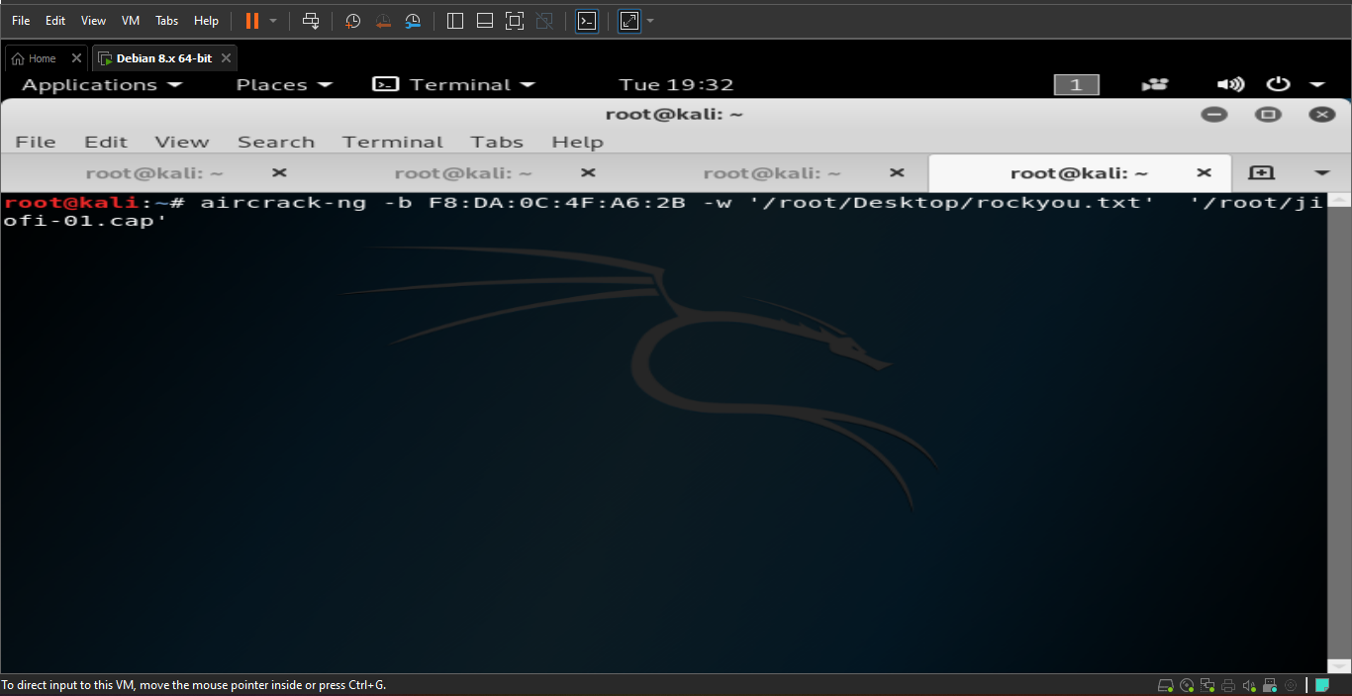



After running the above command we will get like below picture

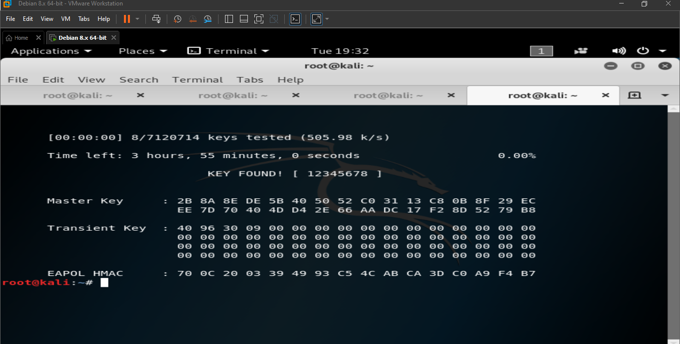

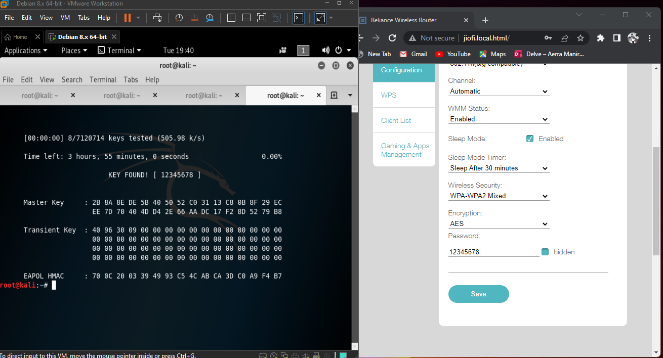

The above picture depicts that password cracked and password of wifi router is found true.

Submitted to: Aerra Board Infinity

Submitted by: Aerra Maniraj